using System;

using System.Collections.Generic;

using System.ComponentModel;

using System.Data;

using System.Drawing;

using System.Linq;

using System.Text;

using System.Windows.Forms;

using System.Data.OleDb;

namespace HCI_ASSIGNMENT

{

public partial class login : Form

{

OleDbConnection connection = new OleDbConnection(@"Provider=Microsoft.ACE.OLEDB.12.0;Data Source=E:\IMS\HCI ASSIGNMENT\stockrecord.accdb;

Persist Security Info=False;");

public login()

{

InitializeComponent();

}

private void button1_Click(object sender, EventArgs e)

{

if (comboBox1.Text=="Admin")

{

if (textBox1.Text=="Admin"&&textBox2.Text=="admin")

{

MessageBox.Show("Password Correct");

this.Hide();

adminlist adminlist = new adminlist();

adminlist.Show();

}

else

{

MessageBox.Show("Password Incorrect");

}

}

else if (comboBox1.Text=="Customer")

{

int count = 0;

connection.Open();

OleDbCommand command = new OleDbCommand();

command.Connection = connection;

command.CommandText = "select * from signup where UserName='" + textBox1.Text + "' and Password='" + textBox2.Text + "'";

OleDbDataReader read = command.ExecuteReader();

while (read.Read())

{

count= count + 1;

}

if (count==1)

{

MessageBox.Show("Password Correct");

this.Hide();

customer_item customerlist = new customer_item();

customerlist.Show();

}

else

{

MessageBox.Show("Password Incorrect");

}

connection.Close();

}

}

private void button2_Click(object sender, EventArgs e)

{

this.Hide();

signup signup = new signup();

signup.Show();

}

private void button3_Click(object sender, EventArgs e)

{

OpenFileDialog ofd = new OpenFileDialog();

if (ofd.ShowDialog() == DialogResult.OK)

{

Bitmap bit = new Bitmap(ofd.FileName);

pictureBox3.Image = bit;

pictureBox3.SizeMode = PictureBoxSizeMode.StretchImage;

}

}

private void label2_Click(object sender, EventArgs e)

{

}

private void label3_Click(object sender, EventArgs e)

{

}

private void label4_Click(object sender, EventArgs e)

{

}

private void comboBox1_SelectedIndexChanged(object sender, EventArgs e)

{

}

private void login_Load(object sender, EventArgs e)

{

}

}

}

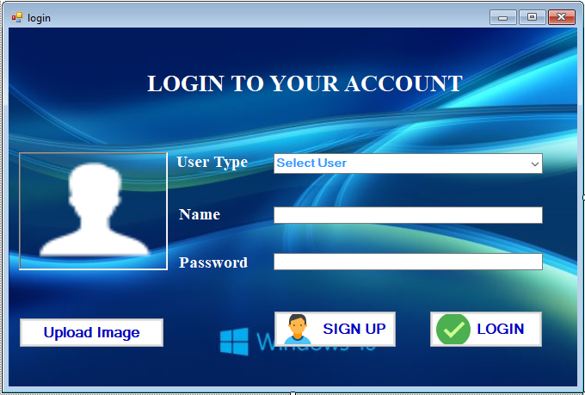

using System;

using System.Collections.Generic;

using System.ComponentModel;

using System.Data;

using System.Drawing;

using System.Linq;

using System.Text;

using System.Windows.Forms;

using System.Data.OleDb;

namespace HCI_ASSIGNMENT

{

public partial class signup : Form

{

OleDbConnection connection = new OleDbConnection(@"Provider=Microsoft.ACE.OLEDB.12.0;Data Source=E:\IMS\HCI ASSIGNMENT\stockrecord.accdb;

Persist Security Info=False;");

public signup()

{

InitializeComponent();

}

private void button2_Click(object sender, EventArgs e)

{

connection.Open();

OleDbCommand cmd = connection.CreateCommand();

cmd.CommandType = CommandType.Text;

cmd.CommandText = "insert into signup values('" + textBox0.Text + "','" + textBox1.Text + "','" + textBox2.Text + "')";

cmd.ExecuteNonQuery();

MessageBox.Show(" Successfully Signed Up!!! ");

connection.Close();

}

private void button1_Click(object sender, EventArgs e)

{

this.Hide();

login login = new login();

login.Show();

}

}

}

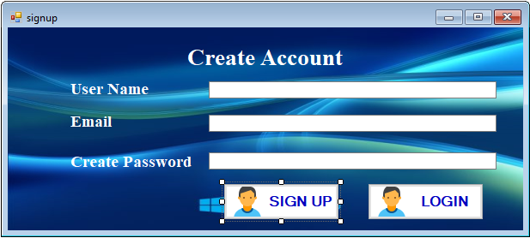using System;

using System.Collections.Generic;

using System.ComponentModel;

using System.Data;

using System.Drawing;

using System.Linq;

using System.Text;

using System.Windows.Forms;

using System.Data.OleDb;

namespace HCI_ASSIGNMENT

{

public partial class adminlist : Form

{

OleDbConnection connection = new OleDbConnection(@"Provider=Microsoft.ACE.OLEDB.12.0;Data Source=E:\IMS\HCI ASSIGNMENT\stockrecord.accdb;

Persist Security Info=False;");

int count;

public adminlist()

{

InitializeComponent();

}

private void button5_Click(object sender, EventArgs e)

{

this.Close();

}

private void panel1_Paint(object sender, PaintEventArgs e)

{

}

private void button1_Click(object sender, EventArgs e)

{

}

private void button2_Click(object sender, EventArgs e)

{

}

private void adminlist_Load(object sender, EventArgs e)

{

}

private void button3_Click(object sender, EventArgs e)

{

}

private void button4_Click(object sender, EventArgs e)

{

}

private void button5_Click_1(object sender, EventArgs e)

{ count =0;

connection.Open();

OleDbCommand cmd = connection.CreateCommand();

cmd.CommandType = CommandType.Text;

cmd.CommandText = "select * from adminview where ItemName='"+textBox7.Text+"'";

cmd.ExecuteNonQuery();

DataTable dt = new DataTable();

OleDbDataAdapter da = new OleDbDataAdapter(cmd);

da.Fill(dt);

count = Convert.ToInt32(dt.Rows.Count.ToString());

dataGridView1.DataSource = dt;

connection.Close();

if (count==0)

{

MessageBox.Show("Data Not Available");

}

}

private void button7_Click(object sender, EventArgs e)

{

connection.Open();

OleDbCommand cmd = connection.CreateCommand();

cmd.CommandType = CommandType.Text;

cmd.CommandText= "insert into adminview values('"+textBox1.Text+"','"+textBox2.Text+"','"+textBox3.Text+"')";

cmd.ExecuteNonQuery();

MessageBox.Show("Data Inserted");

connection.Close();

}

private void button1_Click_1(object sender, EventArgs e)

{

connection.Open();

OleDbCommand cmd = connection.CreateCommand();

cmd.CommandType = CommandType.Text;

cmd.CommandText = "select * from adminview";

cmd.ExecuteNonQuery();

DataTable dt = new DataTable();

OleDbDataAdapter da = new OleDbDataAdapter(cmd);

da.Fill(dt);

dataGridView1.DataSource = dt;

connection.Close();

}

private void button6_Click(object sender, EventArgs e)

{

connection.Open();

OleDbCommand cmd = connection.CreateCommand();

cmd.CommandType = CommandType.Text;

cmd.CommandText = "delete from adminview where ItemName='" + textBox8.Text + "'";

cmd.ExecuteNonQuery();

MessageBox.Show("Data Deleted");

connection.Close();

}

private void button8_Click(object sender, EventArgs e)

{

connection.Open();

OleDbCommand cmd = connection.CreateCommand();

cmd.CommandType = CommandType.Text;

cmd.CommandText = "update adminview set ItemName='" + textBox4.Text + "' where ItemName='"+textBox1.Text+"'";

cmd.ExecuteNonQuery();

MessageBox.Show("Data Updated");

connection.Close();

}

private void button2_Click_1(object sender, EventArgs e)

{

textBox1.Clear();

textBox2.Clear();

textBox3.Clear();

textBox4.Clear();

textBox5.Clear();

textBox6.Clear();

textBox7.Clear();

textBox8.Clear();

}

private void label9_Click(object sender, EventArgs e)

{

this.Hide();

login lgn = new login();

lgn.Show();

}

private void label1_Click(object sender, EventArgs e)

{

}

}

}

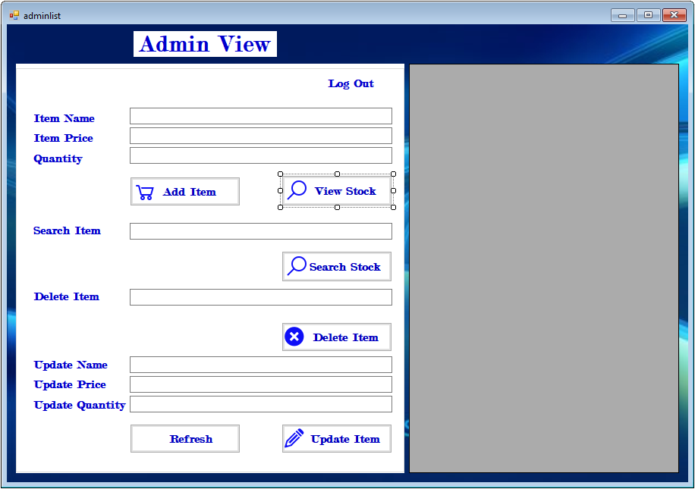using System;

using System.Collections.Generic;

using System.ComponentModel;

using System.Data;

using System.Drawing;

using System.Linq;

using System.Text;

using System.Windows.Forms;

using System.Data.OleDb;

namespace HCI_ASSIGNMENT

{

public partial class customer_item : Form

{

OleDbConnection connection = new OleDbConnection(@"Provider=Microsoft.ACE.OLEDB.12.0;Data Source=E:\IMS\HCI ASSIGNMENT\stockrecord.accdb;

Persist Security Info=False;");

public customer_item()

{

InitializeComponent();

}

private void customer_item_Load(object sender, EventArgs e)

{

}

private void button1_Click(object sender, EventArgs e)

{

}

private void button2_Click(object sender, EventArgs e)

{

}

private void button8_Click(object sender, EventArgs e)

{

int count = 0;

connection.Open();

OleDbCommand cmd = connection.CreateCommand();

cmd.CommandType = CommandType.Text;

cmd.CommandText = "select * from adminview where ItemName='" + textBox7.Text + "'";

cmd.ExecuteNonQuery();

DataTable dt = new DataTable();

OleDbDataAdapter da = new OleDbDataAdapter(cmd);

da.Fill(dt);

count = Convert.ToInt32(dt.Rows.Count.ToString());

dataGridView1.DataSource = dt;

connection.Close();

if (count == 0)

{

MessageBox.Show("Data Not Available");

}

}

private void button4_Click(object sender, EventArgs e)

{

textBox7.Clear();

}

private void label9_Click(object sender, EventArgs e)

{

this.Hide();

login lgn = new login();

lgn.Show();

}

}

}

